

**2023 / 2024**

**Project Spécification**

**Réalisé par: Aziz Ben Ismail / Aziz Charada / Aziz Ben Hmida / Amen Allah jouini / Oumayma touil**

**Encadré par: Asma Ayari**







1. Dedication 3

2. Introduction 4

• Problematic 4

3. Overall description 4

a. Project purpose 4

b. Project description 4

c. Project scope 5

• Overview 5

• Features 5

• Deliverables 6

d. Assumptions / Constraints / Standards 6

• Assumptions: 6

• Constraints: 6

• Standards: 6

4. Study of the existing 7

• Kickstarter 7

• Gofundme 7

• Green Funder 7

a. Critic of the existing 7

Green Funder 8

5. Proposed Solution 8

a. Actors 8

Admin 8

FabLab 8

User 9

b. Main features 9

c. Added value 9

Eco-friendly focus 9

AI-powered validation 9

Collaboration with FabLabs 10

Job creation 10

User engagement 10

6. Business features specification (V) 10

7. Technical specification 12

a. Technical architecture : 12

• Logical Architecture: 12

• Physical Architecture: 13

b. Languages and frameworks 14

• Express 14

• React 15

c. Software tools 15

• Visual Studio Code 15

• Git & GitHub 16

d. Material tools 16

e. Advanced Technologies 16

Artificial Intelligence 16

Chat and Video Call: 16

8. Other requirements 16

1. Dedication

we would like to sincerely thank you for your valuable help throughout the preparation of our web application report. Your support, insightful advice and expertise have been of great assistance to us.

Your patience, availability and ability to guide us with tact and kindness have been essential in enabling us to work collaboratively and ensure a quality-work.

We are extremely grateful for all that you have done for us, and we want to express our heartfelt appreciation for your commitment and dedication. We have been fortunate to have such a competent and attentive tutor, and we hope to have the opportunity to work with you again in the future.

Once again, thank you very much for everything.

1. Introduction

In recent years, the world has seen an increase in awareness regarding environmental issues and the need for sustainable development. This has led to a growing interest in eco-friendly solutions that can help reduce the negative impact of human activities on the environment. One area where this trend is particularly evident is in the field of crowdfunding, where many individuals and organizations are looking to support environmentally friendly projects.

Welcome to our platform, a unique crowdfunding platform designed to support ecological projects in Africa. Our platform is a revolutionary tool that enables environmentally-conscious entrepreneurs to take their validated projects to the next level by finding motivated employees in their field and accessing the resources of fab labs.

* Problematic

However, despite this growing interest, there are still many challenges facing the development of environmentally friendly crowdfunding projects, particularly in regions like Africa. For example, there may be a lack of knowledge or resources to create such projects, as well as a lack of platforms dedicated to promoting and supporting eco-friendly initiatives.

Moreover, there may be issues related to the validation and verification of project descriptions to ensure that they meet eco-friendly criteria, as well as challenges in attracting investors and supporters for these projects. These challenges highlight the need for a dedicated crowdfunding platform that is focused on supporting environmentally friendly projects in Africa, while addressing the various challenges that may arise.

1. Overall description
   1. Project purpose

The purpose of the project is to create a crowdfunding platform specifically focused on supporting environmentally friendly projects in Africa. The platform will connect project creators with investors and supporters, and provide resources and support to ensure that projects meet eco-friendly criteria.

* 1. Project description

The platform will feature three user roles: an administrator who manages the platform, a "fablab" that can support projects and provide training and encouragement for creators, and individual users who can create and invest in projects. Each user will have access to a chat and video call system to facilitate communication and collaboration.

When an individual user creates a project, its description will be validated by an artificial intelligence model to determine if it meets eco-friendly criteria. If the project passes validation, it will be displayed in the platform's menu and other users can invest in it. If the project fails validation, it will only be displayed in the project creator's "manage your project" section and labeled as non-ecological. The project creator will have the option to modify the project description to make it eco-friendly, and resubmit it for validation.

When a project reaches its funding goal, it will be displayed on a separate page where individuals can apply to work on the project. The platform will also offer badges to users for creating projects or investing in them.

* 1. Project scope
* **Overview**

The project's main goal is to develop a crowdfunding platform that is dedicated to supporting ecologically-friendly projects in Africa. The platform will enable users to create and invest in environmentally conscious projects, and will also provide resources to support project creators in the form of a fablab that can offer training and equipment to help bring their ideas to life. The platform will use artificial intelligence to verify that project descriptions meet the 95% eco-friendly criteria, and will distribute badges to recognize and incentivize environmentally conscious behavior.

* Features

The platform will have three main user roles: Admin, Fablab, and User. Admin will have overall control of the application, while Fablab will be responsible for supporting projects and organizing events to encourage and train project creators. Users will be able to create and invest in projects, and all project descriptions will be subject to review by the AI model before being published on the platform.

The platform will also have a chat and video call feature to facilitate communication between users, as well as a system to distribute badges to recognize environmentally conscious behavior. Finally, the platform will have a page dedicated to job openings for successful projects, where interested individuals can apply to work on them.

* **Deliverables**

The project will deliver a fully functional crowdfunding platform with the ability to create and invest in environmentally conscious projects, as well as support and resources to help project creators bring their ideas to life. The platform will include an AI model to verify project descriptions, as well as a badge system to incentivize and recognize environmentally conscious behavior. The platform will also have a chat and video call feature to facilitate communication between users, and a job openings page for successful projects..

* 1. Assumptions / Constraints / Standards

The Web Application will be developed using the latest web technologies and standards. The site must be secure, reliable, and easy to use. The site must also be compliant with all applicable privacy and security regulations.

* Assumptions:

The users have access to the internet and the necessary hardware and software to use the application.

The users are interested in supporting environmentally friendly projects in Africa.

The projects submitted on the platform will be mainly focused on environmentally friendly initiatives.

* Constraints:

The application will only be available in Africa.

The project should be ecologically friendly, with a minimum of 95% focus on sustainability.

The application should have the ability to integrate with payment gateways and ensure secure transactions.

The AI model used for project validation will be based on existing data and will not be able to guarantee 100% accuracy.

* Standards:

The application will comply with all applicable data privacy and security regulations.

The application will have an intuitive and user-friendly interface.

The application will be optimized for performance and scalability.

1. Study of the existing

* Kickstarter

Kickstarter is a well-known crowdfunding platform that launched in 2009. It is a reward-based crowdfunding platform where project creators set a funding goal and offer rewards to backers who pledge money towards the project. Kickstarter charges a fee of 5% of the total amount raised, plus payment processing fees. Kickstarter has funded a wide range of projects, from art installations to technology products.

* Gofundme

GoFundMe is a popular crowdfunding platform that allows individuals to raise funds for personal causes, such as medical bills, education expenses, or community projects. It is also a reward-based platform, where donors receive perks or incentives in exchange for their support. GoFundMe charges a fee of 2.9% plus $0.30 per donation, but there are no penalties for missing a funding goal.

* Green Funder

Green Funder is a crowdfunding platform specifically focused on environmental and sustainability projects. It allows project creators to set up fundraising campaigns and offer rewards to backers in exchange for their support. Green Funder charges a fee of 5% of the total amount raised, plus payment processing fees.

this platform does not have a specific focus on African projects, which is a key aspect of our crowdfunding web application

* 1. Critic of the existing

**Kickstarter** is one of the most well-known crowdfunding platforms and has successfully funded a large number of projects. It has a strong community and offers a user-friendly interface for both project creators and backers. However, Kickstarter has faced criticism for its strict rules and regulations regarding project approval, which may limit the types of projects that can be launched.

**GoFundMe** is a popular platform for personal fundraising and has been used for various causes, including medical expenses, education, and charity events. It offers a simple and easy-to-use interface, allowing users to launch their campaigns quickly. However, GoFundMe has also faced criticism for its fees and lack of support for project creators.

Green Funder is a relatively new crowdfunding platform that focuses on supporting environmentally-friendly projects. It offers a unique niche for projects that are specifically designed to benefit the environment. However, it may face challenges in attracting a large enough audience, given its narrow focus.

**Overall**, each platform has its strengths and weaknesses, and choosing the right one depends on the specific needs and goals of the project.

1. Proposed Solution

The proposed solution is an online crowdfunding platform specifically designed for eco-friendly projects in Africa. The platform will provide a user-friendly interface for creators and investors to participate in creating and funding eco-friendly projects that have a positive impact on the environment.

The platform will incorporate a sophisticated Artificial Intelligence (AI) model to evaluate the projects' ecological impact and ensure that they meet the 95% eco-friendliness requirement before being published. The platform will also offer a supportive environment for creators by providing access to Fablabs, where they can receive expert guidance on their projects and participate in events and training sessions to improve their skills.

Users will have access to a chat and video call feature for direct communication between investors and creators, enhancing collaboration and creating a strong sense of community.

The platform will also implement a badge system to incentivize creators and investors to engage more actively on the platform. Creators can earn badges for creating multiple eco-friendly projects, and investors can earn badges for supporting multiple eco-friendly projects.

Overall, the proposed solution aims to provide a unique and much-needed platform that caters specifically to eco-friendly projects in Africa, encourages creators to adopt environmentally conscious practices, and provides a supportive community for investors and creators alike.

* 1. Actors

Admin: The admin is responsible for managing the entire application, including user registration and management, project approval and management, and overall site functionality.

FabLab: The FabLab is an organization that supports projects and creates events to train and encourage project creators. They have the ability to support projects on the platform and can provide additional resources for the projects they choose to support.

User: The user is the primary actor in the application. They can create projects, invest in other projects, and apply for jobs on projects that have reached their funding goals. The user also has access to a chat and video call feature to interact with other users on the platform.

* 1. Main features

**User registration and profile creation**: Users can create accounts, complete their profile information, and manage their account settings.

**Project creation**: Users can create project proposals, including a detailed description of the project, the required funding amount, and the expected environmental impact.

**Project validation and approval**: Projects are reviewed by an AI model to determine their level of eco-friendliness. Projects that meet the 95% eco-friendly requirement are approved for funding.

**Fundraising**: Users can invest in approved projects and track the progress of their investment. The platform can use a payment gateway to securely process transactions.

**FabLab support**: Users can connect with FabLabs to receive technical assistance, advice, and mentorship throughout the project lifecycle.

**Project management**: Project creators can manage their projects, including updating project information, communicating with supporters, and monitoring funding progress.

**Project completion**: When a project is fully funded, users can apply for employment opportunities related to the project or earn badges and rewards for their contributions.

**Communication tools**: Users can communicate with other users, project creators, and FabLabs through a messaging system, chat, or video calls.

* 1. Added value

Eco-friendly focus**:** Our platform will only support projects that are ecologically sustainable, with a minimum threshold of 95% ecological sustainability. This will make our platform unique and appeal to a growing segment of socially conscious consumers who are looking for ways to invest their money in environmentally responsible projects.

AI-powered validation: To ensure that all projects meet our stringent ecological criteria, we will use an AI-powered model to validate each project's description. This will ensure that only projects that are genuinely environmentally sustainable will be approved for funding.

Collaboration with FabLabs: We will partner with local FabLabs to provide support to project creators. FabLabs will be able to offer advice on design and production, as well as organize training events to encourage the development of new and innovative eco-friendly projects.

Job creation: Our platform will create new jobs by funding eco-friendly projects that require additional resources to reach completion. As these projects grow, they will create new employment opportunities, further contributing to the growth of the green economy.

User engagement: Our platform will offer a range of features to engage users and encourage participation. This will include a badge system that rewards users for creating and investing in eco-friendly projects, as well as chat and video call features to facilitate communication between users.

1. Business features specification (V)

|  |  |  |  |
| --- | --- | --- | --- |
| **Module** | **Submodules** | **System features** | **Description** |
| project and investment management | project management | System feature 1.1.1 | Ability to create a project by entering a title, description, image and fundraising goal |
| System feature 1.1.2 | Ability to modify a project |
| System feature 1.1.3 | Ability to delete a project |
| System feature 1.1.4 | Possibility to consult my projects |
| investment management | System feature 1.2.1 | Ability to invest in a project |
| System feature 1.2.2 | Ability to modify an invest in a project |
| System feature 1.2.3 | Ability to consult my investments |
| System feature 1.2.4 | Ability to delete an invest in a project |
| User management  And chat | User management | System feature 1.1.1 | Ability to sign up and sign in |
| System feature 1.1.2 | Ability to modify user (profile) |
| System feature 1.1.3 | Ability to delete user |
| System feature 1.1.4 | Ability to view profile |
| chat | System feature 1.2.1 | Ability to send a message |
| System feature 1.2.2 | Ability to view messages |
| System feature 1.2.3 | Ability to delete message |
| System feature 1.2.4 | Ability to update message |
| Fablabs Management | Fablabs Management | System feature 1.1.1 | Ability to join the platform after an administrative approval. |
| System feature 1.1.2 | Ability to support a project idea. |
| System feature 1.1.3 | Ability to discuss with the person behind the idea. |
| System feature 1.2.1 | Ability to create an event |
| Event  Management | System feature 1.2.2 | Ability to update an event |
| System feature 1.2.3 | Ability to delete an event |
| System feature 1.2.4 | Ability to consult an event |
| Recruiting Management | Employees Management | System feature 1.1.1 | Ability to add an offer |
| System feature 1.1.2 | Ability to modify an offer |
| System feature 1.1.3 | Ability to delete an offer |
| System feature 1.1.4 | Ability to consult offers |
| Recruiting Management | System feature 1.2.1 | Ability to accept candidates |
| System feature 1.2.2 | Ability to refuse candidates |
| Evaluation management | Evaluation Management | System feature 1.1.1 | Ability to add XP |
| System feature 1.1.2 | Ability to add badges |
| System feature 1.1.3 | Ability to delete badges |
| System feature 1.1.4 | Ability to consult LVL USER |
| Rating management | System feature 1.2.1 | Ability to add rate |
| System feature 1.2.2 | Ability to modify an rate |
| System feature 1.2.3 | Ability to add XP |
| System feature 1.2.4 | Ability to add badges |

1. Technical specification
   1. Technical architecture :

* Logical Architecture:

The logical architecture of the application will consist of the following components:

**User interface:** This will be the front-end of the application, where users can interact with the system.

**Application server:** This will manage the application logic and process user requests.

**Database server:** This will store all application data, including user profiles, project details, and transaction history.

**Machine learning model**: This will be responsible for validating project descriptions based on their ecological impact.

* Physical Architecture:

The physical architecture of the application will consist of the following components:

**Web server:** This will host the web application and manage incoming requests from users.

**Application server:** This will process incoming requests and send responses to the web server.

**Database server:** This will store all application data and be responsible for managing data access and storage.

**Machine learning server:** This will host the machine learning model responsible for validating project descriptions.

All these components will communicate with each other using APIs and will be hosted on cloud servers to ensure scalability and reliability. The application will also leverage the latest security standards to ensure data privacy and integrity.

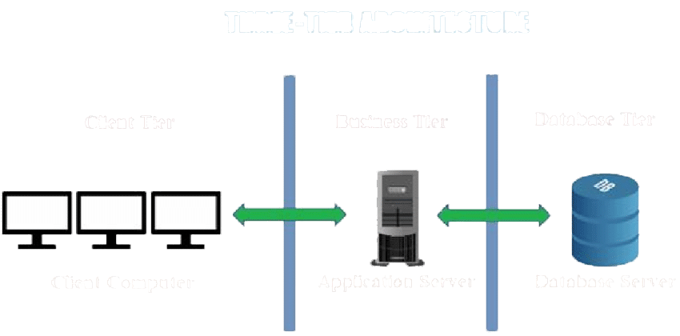

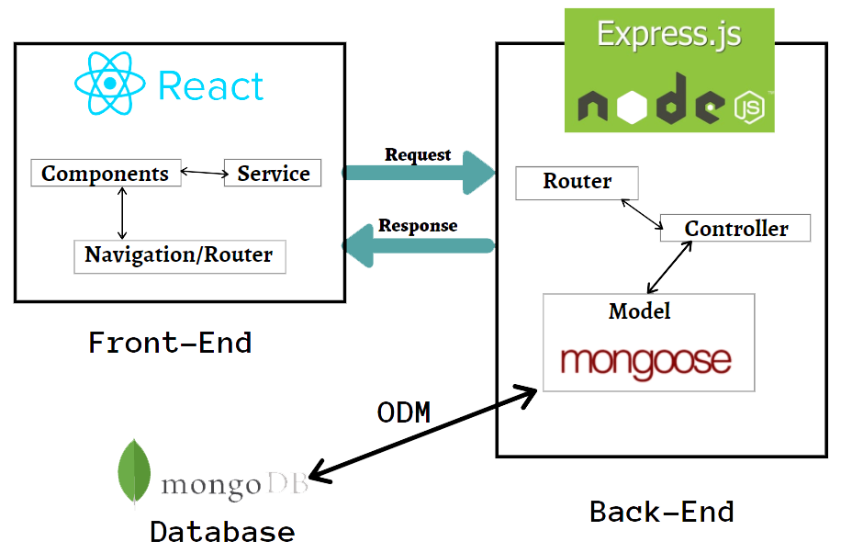

* 1. Languages and frameworks
* Express

Ease of Getting Started**:** Express is a lightweight and easy-to-use library for building web applications, making it a popular choice for beginner developers.

Flexibility:Express is extremely flexible and can be used to build a wide variety of web applications, from simple sites to enterprise level applications.

Interoperability with other technologies:Express can be used in conjunction with other technologies, such as Node.js and MongoDB, to build more complete applications**.**

Rich ecosystem:Express is supported by a large community of developers and has a rich ecosystem of libraries and packages to extend the core functionality of the library.

Abundant documentation and resources:There are an abundance of online resources for learning and using Express, including blog posts, video tutorials, discussion forums, and more.

Speed of development**:** Express facilitates rapid application development by providing features such as HTTP request handling, route handling, and middleware handling, allowing developers to focus on their application's key functionality.

* React

**besoin d'une solution simple et flexible pour construire des interfaces utilisateur**

Ease of Use: React is known for its simplicity and ease of use, making it a popular choice for both new and experienced developers.

High performance: React uses a reconciliation system to manage UI updates, which helps ensure fast and smooth performance for applications.

Component reusability: React encourages component reuse, allowing developers to build applications faster using prebuilt components.

Rich ecosystem: React is supported by a large community of developers and has a rich ecosystem of libraries and packages to extend the core functionality of the library.

Interoperability with other technologies: React can be used with other technologies, such as Node.js, to build more complete applications.

Abundant documents and resources: There are an abundance of online resources for learning and using React, including blog posts, video tutorials, discussion forums, and moresoftware tools

* 1. Software tools
* Visual Studio Code

Friendly User Interface: Visual Studio Code has an intuitive and easy to use user interface that allows developers to work efficiently on their code.

Extensions and Plugins: Visual Studio Code has a large ecosystem of extensions and plugins that can be used to extend software functionality and add additional features for developers.

Built-in debugging features: Visual Studio Code includes built-in debugging features to help developers diagnose and resolve errors in their code.

* Git & GitHub

Outils de développement: Des outils tels que Git, GitHub, Bitbucket ou SVN peuvent être utilisés pour gérer le code source et le suivi des modifications de votre site web.

* 1. Material tools

Personal computer: A personal computer is required to design, develop and manage a crowdfunding site.

Web design software: Software such as Adobe Dreamweaver, Wix or WordPress can be used to design the website.

Web server: To host and run the website, you will need a dedicated web server or a shared web host.

Domain name and storage space: You will need a domain name and storage space to store your website files.

* 1. Advanced Technologies

Artificial Intelligence and Machine Learning: In order to validate the ecological aspects of the projects, an AI model will be trained to analyze and classify the projects based on their environmental impact.

Chat and Video Call: A chat and video call feature will be integrated into the application to facilitate communication between the different actors in the application.

1. Implemented Solution
2. Conclusion

In conclusion, our crowdfunding platform for eco-friendly projects in Africa is a unique solution that addresses the lack of funding for sustainable projects in the continent. Through the use of artificial intelligence and a focus on environmental sustainability, our platform offers a robust set of features that enable users to create, invest, and collaborate on eco-friendly projects. The platform also provides a space for fablabs to support project creators and foster innovation. By leveraging modern technologies such as AI, we believe our platform will help drive positive change in Africa and contribute to a more sustainable future.